Name: _____________________ /52

**Yr 12 Physics Electromagnetism Test 2019**

Instructions

1. Answer all questions in the spaces provided.
2. Give all numerical answers to three significant figures, except where you are required to estimate values where two significant figures will be appropriate.
3. Show all working – marks may be awarded for logical working even when an incorrect final answer is arrived at.
4. If you require extra working space, write “PTO” on the bottom of the page and continue working on the back of the page.

52 marks for answering the questions

Up to 4 marks maybe deducted for incorrect units and significant figures

**QUESTION ONE (4 marks)**

Sketch the magnetic fields around the following:

1. b)

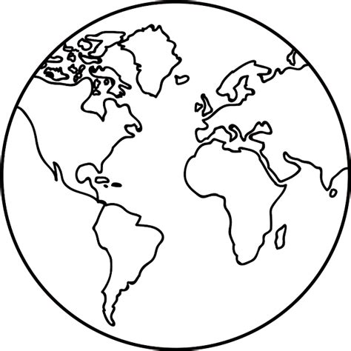 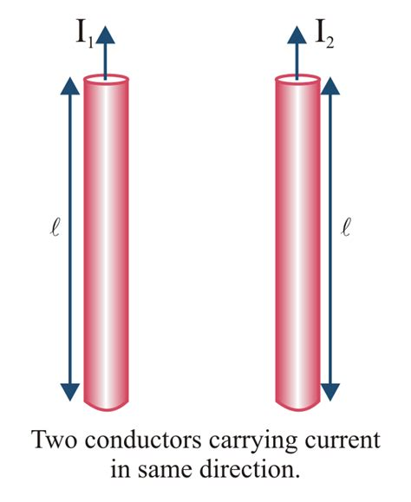

**QUESTION TWO (7 marks)**

A car is travelling west at 72.0km/h on a road in the southern hemisphere where the earth’s magnetic field intensity is 5.00 x 10-5 T, and where the angle of inclination is 32.00 to the horizontal. If the car has an 80.0cm metal radio antenna sticking up vertically on the roof of the car, determine:

1. The amount of flux the antenna sweeps out per second. (4 marks)
2. The EMF generated by the antenna (2 marks)
3. Describe or sketch the electric polarity of the antenna (1 mark)

**QUESTION THREE (6 marks)**

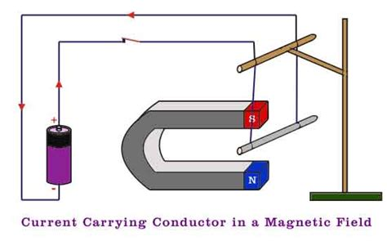

The diagram on the left shows a metal conducting rod hanging from a wooden stand. The battery supplies an EMF of 1.50V, and the circuit has a total resistance of 0.600. The magnetic field strength between the two poles is uniform and has an intensity of 0.0800T.

a) On the diagram indicate clearly with an arrow the direction the conducting metal rod would move when the switch is closed. (1 marks)

1. Explain with the aid of simple, clear sketches, why the rod moves in this direction. (3 marks)
2. Determine the magnitude of the force experienced by the rod. (2 marks)

**QUESTION FOUR** **(24 marks)**

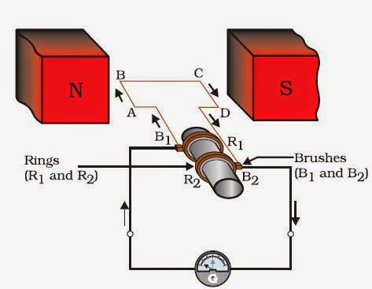

The diagram on the shows the workings of a simple generator.

The coil has 355 square windings, side length 8.50cm, and sits within a uniform magnetic field of intensity 0.485T. The coil rotates at a constant 2450rpm and has a resistance of 0.500.

1. How must the side labelled A-B be moved in order to generate current in the direction shown? (1 mark)
2. Does this device generate AC or DC voltage? How is it possible to determine the type of voltage generated? (2 mark)
3. Determine the maximum flux through the coil. (2 marks)
4. Determine the:
5. **Average** EMF the coil generates. (3 marks)
6. **Peak** EMF the coil generates. (2 marks)
7. On the axes below accurately sketch the voltage versus time trace for 2 full rotations of the coil from the position shown. (4 marks)

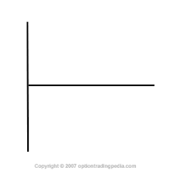

1. The generator is attached directly to a transformer that has 255 windings on its primary side and 3245 windings on its secondary side.
2. Determine the peak secondary voltage of the transformer. (2 marks)
3. Determine the secondary RMS current of the transformer. (3 marks)
4. The generator is then disconnected from the transformer as the owner wishes to convert it into a DC motor. **List** the necessary changes that must be made for this to successfully occur. (2 marks)
5. If these changes were successfully made, and a power source of 24.0V was connected to the coil, determine the maximum force on each side of the motor. (2 marks)
6. Determine the maximum total torque of the motor. (2 marks)

**QUESTION FIVE (11 marks)**

An alpha particle consists of two protons and two neutrons, and has a mass of 6.65 x 10-27 kg. One is fired at 5.56 x 106 m s-1 into a uniform electric field, as shown below, whose two plates are separated by 6.50cm and have 1150V across them.

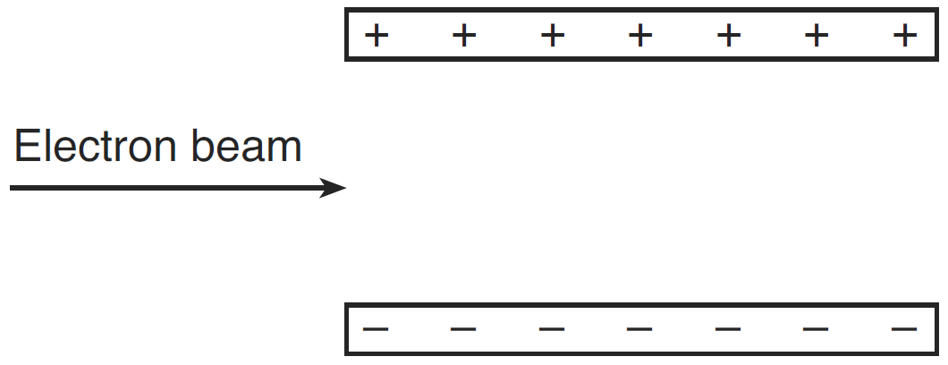

1. On the diagram to the left:
2. Neatly sketch the electric field lines between the plates. (1 mark)
3. Show the direction of the force that the alpha particle experiences. (1 mark)

b) Determine the acceleration experienced by the alpha particle. (3 marks)

c) If the alpha particle was fired into the field, at right angles to the field, exactly halfway between the two plates, determine whether or not it hits a plate or leaves the field, and determine its final velocity (as it either hits a plate or leaves the field). (6 marks)